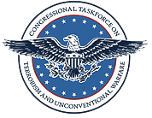

Congressional Taskforce on Terrorism and Unconventional Warfare

2nd Parliamentary Intelligence Security Forum

Vienna, Austria

May 6 - 7, 2015

3rd Parliamentary Intelligence Security Forum

Berlin, Germany

May 8, 2015





Dear Colleague:

Thank you for your continued interest in our Parliamentary Intelligence Security Fora. In May of 2015, we hosted our 2nd and 3rd Fora consecutively in Vienna, Austria and Berlin, Germany where Chairman of the House Permanent Select Committee on Intelligence Devin Nunes; along with the Committee’s Ranking Member Adam Schiff and Members of the Privacy and Civil Liberties Oversight Board (PCLOB), gave presentations. Established by the Implementing Recommendations of the 9/11 Commission, the PCLOB is an independent agency within the executive branch to ensure privacy and civil liberties are balanced against the government’s need to combat terrorism.

The Vienna Forum was a continuance of the first Parliamentary Intelligence-Security Forum held in Washington, D.C. in the fall of 2014 which played host to over 100 Members of Parliament, Ambassadors and officials from 26 countries. The event’s focus was to foster dialogue among the participants on the importance America places on civil liberties. Like the first Forum, the Vienna Forum was widely attended and included representatives from Europe, Eastern Europe, as well as Scandinavia.

More intimate in nature, the Berlin Forum was a bilateral meeting between Chairman Devin Nunes who has oversight over the Intelligence Committee, Chairwoman of the House Committee on Foreign Relations - Illeana Ros-Lehtinen, PCLOB Chairman David Medine, PCLOB Board Member Rachel Brand and senior Members of the German Bundestag. Through two sessions, the U.S. participants provided an in depth and personal briefing to the Bundestag Members on current civil liberty protections, and ways to improve legislative oversight.

Enclosed is the forum’s agenda, a list of panelists, and an official summary of events.

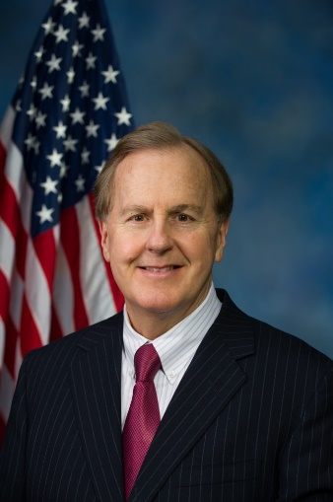We look forward to working with you in the future as we collaborate together to preserve our freedoms and liberties.

Sincerely,

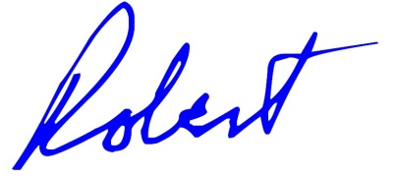

Robert Pittenger

Member of Congress

Chairman, Congressional Taskforce on Terrorism

and Unconventional Warfare

|  |  |  |
| --- | --- | --- |
| **C:\Users\rlusk\AppData\Local\Microsoft\Windows\Temporary Internet Files\Content.Word\Task Force seal 2.png** | **2nd Parliamentary**  **Intelligence-Security Forum**  Wednesday, May 6, 2015 | https://upload.wikimedia.org/wikipedia/commons/thumb/1/1a/Seal_of_the_United_States_House_of_Representatives.svg/1030px-Seal_of_the_United_States_House_of_Representatives.svg.png |

|  |  |  |  |
| --- | --- | --- | --- |
| **1:00 PM** |  | Registration | |
|  |  |  | |
|  |  |  | |
|  |  |  | |
|  |  |  | |
| **2:00 PM** |  | Welcome address by the Austrian delegation | |
|  |  |  | |
|  |  |  | |
| **2:30 PM** |  | Presentation by:   * **David Medine,** *Chairman* *Privacy and Civil Liberties Oversight Board* * **Rachel Brand,** *Member of the Board of the Privacy and Civil Liberties Oversight Board*   Followed by discussion | |
|  |  |  | |
|  |  |  | |
| **3:30 PM** |  | Speech by: | |
|  |  | * **Gerhart Holzinger,**  *President of the Austrian Constitutional Court*   Followed by discussion | |
|  |  |  | |
|  |  |  | |
| **4:30 PM** |  | Coffee Break | |
|  |  |  | |
|  |  |  | |
| **5:00 PM** |  | Speech by:   * **Giovanni Buttarelli,** *European Data Protection Supervisor*     Followed by discussion | |
|  |  |  | |
|  |  |  | |
| **6:00 PM** |  | Transfer to the evening reception | |
|  |  |  | |
|  |  |  | |
| **7:00 PM** |  | Evening Reception  Heuriger “Fuhrgasslhuber”  1190 Vienna, Neustift am Walde 68 | |
|  |  |  | |
|  |  |  | |
| **C:\Users\rlusk\AppData\Local\Microsoft\Windows\Temporary Internet Files\Content.Word\Task Force seal 2.png**  **9:00 AM** |  | https://upload.wikimedia.org/wikipedia/commons/thumb/1/1a/Seal_of_the_United_States_House_of_Representatives.svg/1030px-Seal_of_the_United_States_House_of_Representatives.svg.png **2nd Parliamentary**  **Intelligence-Security Forum**  Thursday, May 7, 2015  Opening Remarks:   * **Wernor Amon,** *Chairman of the Standing Subcommittee on Control of Measures for the Protection of the Constitution* | |
|  |  |  | |
| **9:15 AM** |  | Presentation by: | |
|  |  |  | |
|  |  | * **Iain Cameron,** *University of Uppsala*   Followed by discussion | |
| **10:00 AM** |  | Remarks by: |
|  |  | * **Congressman Robert Pittenger,** *Chairman of the Congressional Task Force on Terrorism and Unconventional Warfare* | |
| **10:15 AM** |  | Presentation by: | |
|  |  | * The Chairman of the Permanent Select Committee on Intelligence for the U.S. House of Representatives, **Devin Nunes,** and Ranking Member of the Permanent Select Committee on Intelligence for the U.S. House of Representatives, **Adam Schiff**   Followed by discussion | |
|  |  |  | |
| |  |  |  | | --- | --- | --- | | **11:15 AM** |  | Coffee Break | |  | Coffee Break | |
| **11:45 AM** |  | Presentation by:   * **Manuel Marion,**  OSCE Deputy Head on Anti-Terrorism Issues   Followed by discussion | |
| **12:30 PM** |  | Transfer to the Parliament Building  1017 Vienna, Dr. Karl Renner – Ring 3 | |

**1:00 PM** Reception on Invitation of the President of the Austrian National Council, **Doris Bures**

**2:00 PM** End of the official Programme

**2:30 PM** Cultural Programme

Visit of the “Kunsthistorisches Museum”

1010 Vienna, Burgring 5

**4:00 PM** End of Cultural Programme

Congressman Pittenger addresses Members of Parliament, Ambassadors and officials from 27 countries on Intelligence procedures, safeguards, and protections for privacy and civil liberties.

## cid:1A20787223DC504B90FF8A40284E7E6A@mail.house.gov

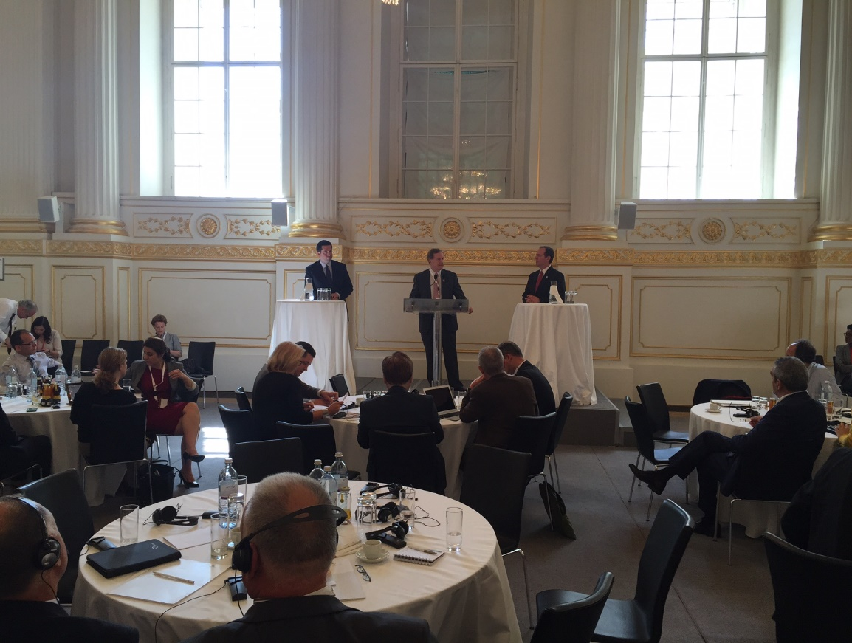

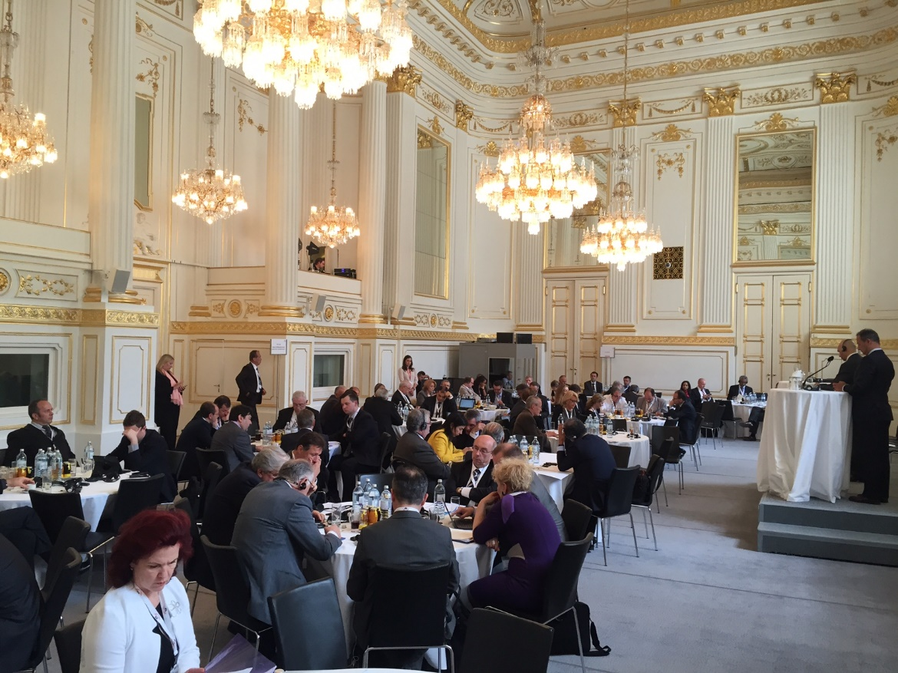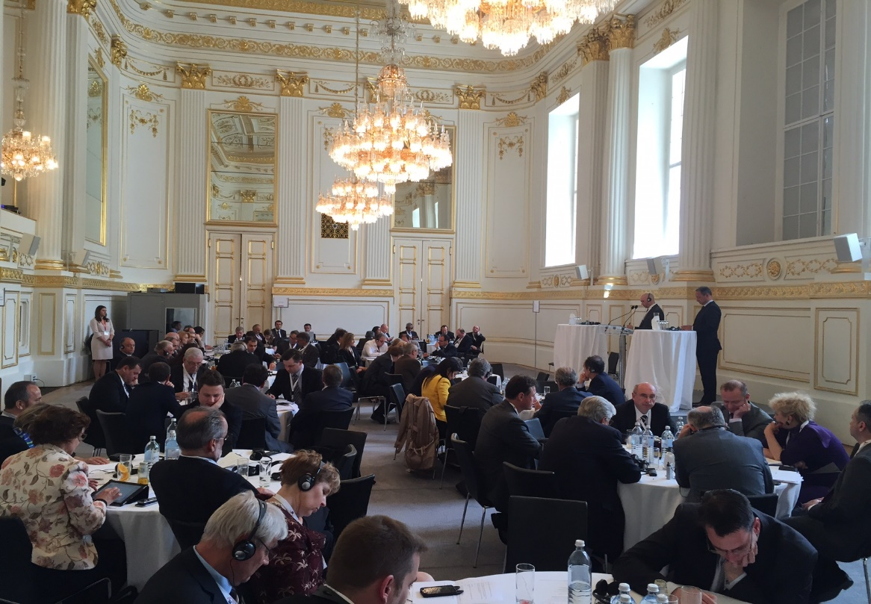

## 2nd Parliamentary Intelligence Security Forum RSVPs

* **Arta Dade,** *Fmr Foreign Affairs Minister, Albania*
* **Taulant Balla,** *Majority Leader, Albania*
* **Fatmir Mediu,** *Member of Parliament, former Defense Minister, Albania*
* **Gramoz Ruci,** *Speaker of Parliament, Albania*
* **Karlheinz Kopf,** *Member of Parliament, Austria*
* **Andreas Schieder,** *Member of Parliament, Austria*
* **Werner Amon,** *Member of Parliament, Austria*
* **Bernd Schonegger,** *Member of Parliament, Austria*
* **Peter Pilz,** *Member of Parliament, Austria*
* **Jessi Lintl,** *Member of Parliament, Austria*
* **Christoph Vavrik,** *Member of Parliament, Austria*
* **Andreas Karlsbock,** *Member of the National Council for the Freedom Party, Austria*
* **Florien Steininger,** *Political Staff, Austria*
* **Alice Irvin,** *Political Staff, Austria*
* **Brigitte Brenner,** *Ambassador, Head of the EU- and International Services, Austria*
* **Joseph Wirnsperger,** *Deputy Head of the EU- and International Services, Austria*
* **Denis Sidorenko,** *Ambassador to Germany, Belarus*
* **Sergei Andrushkevich,** *Second Secretary, Belarus*
* **Sifet Podzic,** *Chairman of the Defence and Security Committee, Bosnia and Herzegovina*
* **Borislav Bojic,** *Deputy Chairman of Defence and Security Committee, Bosnia and Herzegovina*
* **Borjana Kristo,** *Deputy Chairman of Defence and Security Committee, Bosnia and Herzegovina*
* **Zeljko Grubesic,** *Expert Advisor in the Office of Defense and Security Committee, Bosnia and Herzegovina*
* **Ljiljana Milicevic,** *Secretary in the Office of Defense and Security Committee, Bosnia and Herzegovina*
* **Admir Catic,** *Parliamentary Officer, Bosnia and Herzegovina*
* **Sofia Tsvetkova,** *Head of International Affairs, GERB, Bulgaria*
* **Tsvetan Tsvetanov,** *Member of Parliament, Bulgaria*
* **Dimitar Lazarov,** *Member of Parliament, Bulgaria*
* **Mustafa Karadayi,** *Member of Parliament, Bulgaria*
* **Filip Popov,** *Member of Parliament, Bulgaria*
* **Valentin Kasabov,** *member of the parliamentary Committee on Internal Security and Public Order, Bulgaria*
* **Atanas Atanassov,** *Chairperson Internal Security and Public Order Committee, Bulgaria*
* **Rada Lessidrenska,** *First Secretary at the Embassy to Vienna, Bulgaria*
* **Josip Leko,** *Speaker of the Croatian Parliament, Croatia*
* **Miroslav Tudman,** *Chairperson of the Domestic and National Security Committee, Croatia*
* **Gordan Jandrokovic,** *Deputy Club of the Croatian Democratic Union, Croatia*
* **Gordana Sobol,** *Deputy Club of the Social Democratic Party, Croatia*
* **Durdica Pralas,** *Head of the Office of the Speaker, Croatia*
* **Ilija Jandric***, Adviser of the Speaker, Croatia*
* **Zdeslav Perkovic,** *Head of the Protocol Office, Croatia*
* **Ilija Horvat,** *Security Officer, Croatia*
* **Boris Kajic,** *Security Officer, Croatia*
* **Mario Kljaic,** *Security Officer, Croatia*
* **Oliver Krizic,** *Security Officer, Croatia*
* **Goran Golub,** *Security Officer, Croatia*
* **Gordan Bakota,** *Ambassador, Croatia*
* **Silvio Kus,** *Croatian Embassy in Vienna, Croatia*
* **Charalambos Theopemptou,** *Cyprus House of Representatives, Cyprus*
* **Ioanna Sygrasiti,** *International Relations Officer of the Cyprus House of Representatives, Cyprus*
* **Marios Ieronymides,** *Ambassador, Cyprus*
* **Antonios Demetriades,** *Colonel, Senior Military Adviser of the Embassy in Vienna, Cyprus*
* **Radek Hudecek,** *Defense Attaché at the Czech Embassy in Berlin, Germany, Czech Republic*
* **Radek Vondracek,** *Speaker of the Deputies of the Parliament of the Czech Republic, Czech Republic*
* **Roman Vana,** *Chairman of the Committee on Security of the Chamber of Deputies, Czech Republic*
* **Bronislav Schwarz,** *Vice Chairman of the Committee on Security of the Chamber of Deputies, Czech Republic*
* **May ElBatran,** *Egypt House of Representatives, Egypt*
* **Badr Abdel Atty,** *Egyptian Ambassador to Germany, Egypt*
* **Laurentiu Constantin Rebega,** *Member of Parliament, European Parliament*
* **Irakli Sesiashvili,** *Chairman of Defence and Security, Georgia*
* **Pia Zimmerman,** *Administrative Assistant to the Chairman, Germany*
* **Andreas Frank,** *Advisor to the Council of Europe for the Anti-Money Laundering Directive (AMLD), Germany*
* **Wolfgang Ischinger,** *Chairman of the Munich Security Conference, Germany*
* **James Freis,** *former FinCEN Director, Germany*
* **Rainer Baumgart,** *Law Enforcement Expert, Germany*
* **Doris Bischoff,** *Managing Director and CCO of the Deutsche Borse Group, Germany*
* **Fritz Felgentreu,** *Member of Parliament, Germany*
* **Volkmar Klein,** *Member of Parliament, Germany*
* **Andreas Schwarz,** *Member of Parliament, Germany*
* **Johannes Selle,** *Member of Parliament, Germany*
* **Stephan Mayer,** *Parliamentary State Secretary at the German Federal Ministry of the Interior, Germany*
* **Holger Munch,** *President of the Federal Criminal Police Office of Germany, Germany*
* **Bruno Kahl,** *President of the Federal Intelligence Service, Germany*
* **Dr. Hans-Georg Maaben,** *President of the German Domestic Intelligence Service, Germany*
* **Dr. Konstantin von Notz,** *Vice President of the Parliamentary Oversight Panel, Germany*
* **Jens Peter Singer,** *Senior Government Official, Germany*
* **Kese Beatrix,** *Advisor from the Foreign Affairs Directorate, Hungary*
* **Csaba Hende,** *Deputy Speaker of the National Assembly of Hungary, Hungary*
* **Zoltan Saringer,** *Interpreter, Hungary*
* **Laszlo Kover,** *Speaker of the National Assembly of Hungary, Hungary*
* **Gergely Gulyas,** *Deputy Speaker of the National Assembly, Hungary*
* **Katalin Csobor,** *Member of the National Assembly, Hungary*
* **Matyas Firtl,** *Member of the National Assembly, Hungary*
* **Andras Schiffer,** *Member of the National Assembly, Hungary*
* **Tamas Harangozo,** *Member of the National Assembly, Hungary*
* **Adam Mirkoczki,** *Member of the National Assembly, Hungary*
* **Vajk Farkas,** *Chief of Cabinet of the Deputy Speaker, Hungary*
* **Pat Breen,** *Chairman of the Joint Committee on Foreign Affairs and Trade, Ireland*
* **Niamh Maguire,** *Official, Ireland*
* **Paolo Alli,** *Member of Parliament, Italy*
* **Ksenia Svetlova,** *Member of the Knesset, Israel*
* **Zhanar Akaev,** *Member of Parliament of the Kyrgyz Republic, Kyrgyzstan*
* **Ainars Latkovskis,** *Member of Parliament, Latvia*
* **Inese Lībiņa-Egnere,** *Member of Parliament, Latvia*
* **Solvita Aboltina,** *Chairperson of the National Security Committee, Latvia*
* **Emanuelis Zingeris,** *Member of Parliament, Lithuania*
* **Egidijus Vareikis,** *Member of Parliament, Lithuania*
* **Vytautas Bakas,** *Member of Parliament and Chairman of the Committee on National Security and Defence, Lithuania*
* **Arturas Paulauskas,** *Chair of the Committee on National Security and Defence, Lithuania*
* **Paulius Baciulis,** *Adviser of the National Security and Defence Committee, Lithuania*
* **Emanuelis Zingeris,** *Member of Parliament, Lithuania*
* **Biljana Ognenovska,** *Head of Division, Assembly of the Republic of Macedonia, Macedonia*
* **Vladimir Gjorchev,** *Member of Parliament, Macedonia*
* **Sephora Gauci,** *First Secretary, Embassy of Malta in Berlin, Malta*
* **Dr. Albert Friggieri,** *Malta’s Ambassador to Germany, Malta*
* **Angelo Farrugia,** *Speaker of Parliament, Malta*
* **Godfrey Farrugia,** *Member of Parliament, Malta*
* **Chris Said,** *Member of Parliament, Malta*
* **Nebojsa Kaludjerovic,** *Ambassador of Montenegro to the United States of America, Montenegro*
* **Ranko Krivokapic,** *President of the Parliament and OSCE PA President Emeritus, Montenegro*
* **Marin Radojevic,** *Adviser to the President, Montenegro*
* **Andjela Radunovic,** *Adviser to the President, Montenegro*
* **Dorde Petrovic,** *Security Officer, Montenegro*
* **Ahmet Berat Conkar,** *Chairman of the NATO Parliamentary Assembly, NATO*
* **Erik Akerboom,** *Commissioner of the Police, Netherlands*
* **Christian Tybring-Gjedde,** *Member of Norwegian Parliament and Second Vice Chair of the Standing Committee on Foreign Affairs and Defense, Norway*
* **Kenneth Svendsen,** *Second Vice President of the Strortinget, Norway*
* **Kaare Simensen,** *Member of the Standing Committee on Foreign Affairs and Defence, Norway*
* **Ulf Lerstein,** *Member of the Standing Committee on Justice, Norway*
* **Rune Skjerve,** *Permanent Secretary for the Standing Committee on Foreign Affairs and Defence, Norway*
* **Franklin Morales,** *Embassy of Panama to the United States, Panama*
* **Marek Opiola,** *Member of Parliament, Poland*
* **Eduardo Ferro Rodrigues,** *Speaker of Parliament, Portugal*
* **Sergio Sousa Pinto,** *President of the Parliament Foreign Affairs Committee, Portugal*
* **Raul Maia-Oliveira,** *Legal Adviser, Portugal*
* **Petru Gabriel Vlase,** *Deputy Speaker of Parliament, Romania*
* **Valeriu Stefan Zgonea,** *President of the Chamber of Deputies, Romania*
* **Paul Ionescu,** *Adviser of the Cabinet of the Vice President, Romania*
* **Silvia Davidoiu,** *Ambassador, Romania*
* **Alex Ivaner,** *First Secretary to the Embassy of Romania, Romania*
* **Zoran Dragisic,** *Member of Parliament, Serbia*
* **Dragan Sormaz,** *Member of Parliament, Serbia*
* **Darko Trifunovic,** *Professor, University of Belgrade, Serbia*
* **Nikola Samardzic,** *Professor, University of Belgrade, Serbia*
* **Dr. David Hardoon,** *Chief Data Officer and head, Data Analytics Group, Singapore*
* **Katarína Cséfalvayová,** *Member of Parliament, Slovakia*
* **Anton Hrnko,** *Member of Parliament, Slovakia*
* **Katarína Kokavcová,** *Secretary, Foreign Affairs Committee, Slovakia*
* **Franc But,** *Ambassador of the Republic of Slovenia to the Federal Republic of Germany, Slovenia*
* **Branko Grims,** *Chair of the Committee for the Supervision of Intelligence and Security Services, Slovenia*
* **Zan Mahnic,** *Member of the Committee for the Supervision of Intelligence and Security Services, Solvenia*
* **Vicente Moret Millas,** *Clerk of the Joint Committee on National Security, Spain*
* **Luis Aznar Fernandez,** *Member of the Joint Committee on National Security, Spain*
* **Conrado Escobar,** *Spokesperson of the Home Affairs Committee, Spain*
* **Sebastian Gonzalez,** *Chairperson of the Home Affairs Committee, Spain*
* **Feliu-Joan Guillaumes i Raflos,** *Spokesperson of the Home Affairs Committee, Spain*
* **Julio Villarubia,** *Second Deputy Chairperson of the Home Affairs Committee, Spain*
* **Rosa Ripolles,** *Lawyer of the Home Affairs Committee, Spain*
* **Ulf Pehrsson,** *Vice President Government and Industry Relations, Sweden*
* **Bjorn Soder,** *Second Deputy Speaker, Sweden*
* **Arhe Hamednaca,** *Member of Parliament, Sweden*
* **Anti Avsan,** *Member of Parliament, Sweden*
* **Sarah Sidibe,** *Civil Servant, Sweden*
* **Hans Altherr,** *Senator and Member of the Defence Committee of the Council of States, Switzerland*
* **Ashlee Godwin,** *Foreign Affairs Committee Specialist—Joint Committee on the National Security Strategy, United Kingdom*
* **Mark Pritchard,** *Member of Parliament, United Kingdom*
* **John Spellar,** *Member of Parliament, United Kingdom*
* **Madeleine Moon,** *Member of Parliament, United Kingdom*
* **Yvette Cooper,** *Member of Parliament, United Kingdom*
* **Frederick Reynolds,** *Barclays, United States*
* **John Walsh,** *CEO SightSpan, United States*
* **Gabrielle Haddad,** *Co-Founder and COO of Sigma Ratings Inc., United States*
* **Kristin Reif,** *Director Illicit Trade Prevention, United States*
* **Hope Hutchinson,** *EUCOM Liaison, United States*
* **Jessica Knight Abell,** *Managing Director, United States*
* **Andrew Davenport,** *Prague Security Studies Institute and RWR Advisory Services, United States*
* **J.R. Helmig,** *SAS, United States*
* **Jeffrey Kratzer,** *US Customs and Border Protection Attaché—US Embassy Berlin, United States*
* **Andrea Detjen,** *US Customs and Border Protection Senior Analyst—US Embassy Berlin, United States*
* **Devin Nunes,** *Chairman, U.S. House of Representatives Select Committee on Intelligence, United States*
* **Adam Schiff,** *Ranking Member, U.S. House of Representatives Select Committee on Intelligence, United States*
* **Robert Pittenger,** *Member, U.S. House of Representatives Financial Services Committee, United States*
* **David Medine,** *Chairman Privacy and Civil Liberties Oversight Board, United States*
* **Rachel Brand,** *Board Member Privacy and Civil Liberties Oversight Board, United States*
* **Damon Nelson,** *Professional Staff Member, United States*
* **Timothy Bergreen,** *Professional Staff Member, United States*
* **George Pappas,** *Congressional Escort Officer, United States*
* **Jane Bocklage,** *First Secretary, U.S. Embassy Vienna, United States*
* **Leo Stollwitzer,** *Analyst, U.S. Embassy Vienna, United States*
* **Gerhart Holzinger,** *President of the Austrian Constitutional Court*
* **Giovanni Buttarelli,** *European Data Protection Supervisor*
* **Iain Cameron,** *University Uppsala*
* **Manuel Marion,** *OSCE Deputy Head on Anti-Terrorism Issues*
* **Sasha Nikolova,** *Bulgarian Interpreter*
* **Iva Miskovic,** *Croatia Interpreter*
* **Zoltan Saringer,** *Hungary Interpreter*
* **Andrea Rohaly,** *Hungary Interpreter*
* **Lukas Nussi,** *Austrian Parliament Organizer*
* **Julia Loretta Krajcik,** *Austrian Parliament Organizer*
* **Nadine Dragan,** *Austrian Parliament Organizer*
* **Evelyn Seidler,** *Austrian Parliament Organizer*
* **Vanja Plavotic,** *Austrian Parliament Organizer*
* **Nicole Mason,** *Austrian Parliament Organizer*

## Summary of Presentations

**Vienna Forum:**

**Mr. David Medine, *Chairman of the Privacy and Civil Liberties Oversight Board (PCLOB), an independent agency within the executive branch of the U.S. Government established by the Implementing Recommendations of the 9/11 Commission to safeguard privacy and civil liberties with respect to the U.S. Governments mandate to protect its citizens against terrorist activities***

**Rachel Brand*, Member of the Board of the Privacy and Civil Liberties Oversight Board***

Chairman Medine and Board Member Brand provided in depth overviews into the existing privacy protections currently in place, including how those protections are afforded to non-U.S. citizens.

**Congressman Robert Pittenger, *Chairman of the Congressional Taskforce on Terrorism and Unconventional Warfare***

Congressman Pittenger emphasized his desire for the U.S. to work with its allies and encouraged the thoughtful and respectful cooperation of everyone involved.

He underscored the fact that the United States and Europe share democratic values which are being threatened by Islamist jihadist terrorists. And that it is paramount for the U.S. and its allies to work in close collaboration, trust and mutual respect to ensure that the freedoms we cherish are protected.

Congressman Pittenger reaffirmed the importance America places on civil liberties while stressing the fact that the Forum’s meaningful dialogue had clarified many concerns and issues raised by allies of the United States.

***Chairman of the House Permanent Select Committee on Intelligence*** **Devin Nunes**; ***along with the Committee’s Ranking Member*** **Adam Schiff**

Chairman Nunes and Ranking Member Schiff conveyed the strict oversight Congress is able to exercise over the U.S. intelligence community. Given most European Parliaments do not maintain these same capabilities; it was deemed an important discussion on how they can play a more active role in their government’s intelligence gathering activities.

**Berlin Forum:**

The Berlin Forum was an intimate bilateral meeting between Chairman **Devin Nunes** who has oversight over the Intelligence Committee, Chairwoman of the House Committee on Foreign Relations - **Illeana Ros-Lehtinen**, PCLOB Chairman **David Medine**, PCLOB Board Member **Rachel Brand** and senior Members of the German Bundestag and government; including but not limited to such notable Members of the German government as **Dr. Patrick Sensburg**, Chairman of the Examination Committee (NSA) and **Mr. Stephen Mayer**, Member of the Internal Affairs Committee.

Through two sessions, the U.S. participants provided an in depth and personal briefing to the Bundestag Members and senior government officials on current civil liberty protections and ways to improve legislative oversight.

**Conclusion for the Vienna and Berlin Fora:**

These two events provided U.S. policymakers with meaningful fora to engage with key allies on issues of national and world security while affording Members of Congress and the delegation the opportunity to deepen the trust between the United States and world leaders. Through continued dialogue, all sides will gain a better and more complete understanding of each other, as well as the policies the United States is committed to in protecting the safety and civil liberties of its citizens.